

**Virtual Box Setup**

1. **Update Virtual Box to avoid any version conflict** 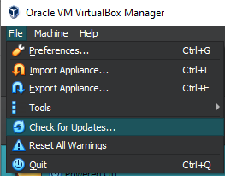
2. **Make sure Virtualization is on for your Processing Platform ( in my case AMD )**
3. **Install Windows 7 Client**
   1. Download provided ISO file from Google Drive 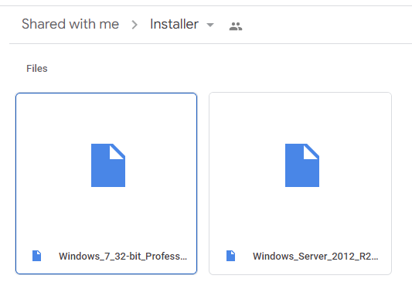
   2. Once file is downloaded onto the system, create a new virtual machine using Virtual Box – Make sure to find the ISO image and name your VM

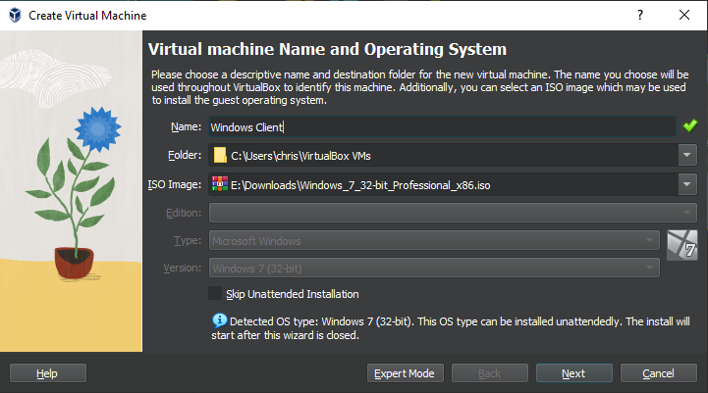

* 1. Personalize Hardware specifications 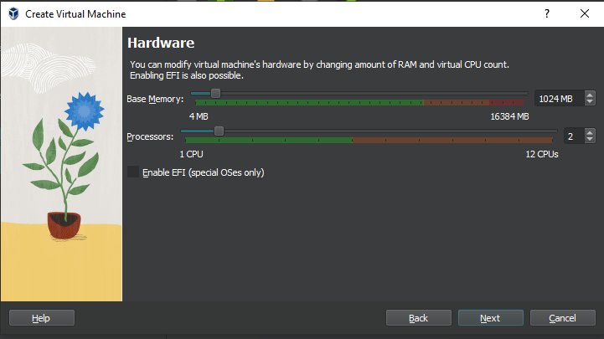
  2. Virtual Hard Disk 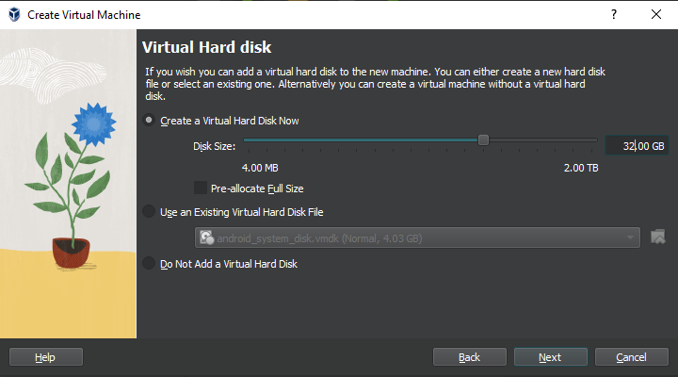

1. **Make sure that you use 2 network adapters (1 as Internal Adapter and another 1 as NAT for Internet Connection)**
2. **Install Windows Server**

*\*Repeat Step 2 but use Windows Server ISO instead*

1. **Setup Windows in Virtual Machine for both OS**
   1. Select preferred language and keyboard input

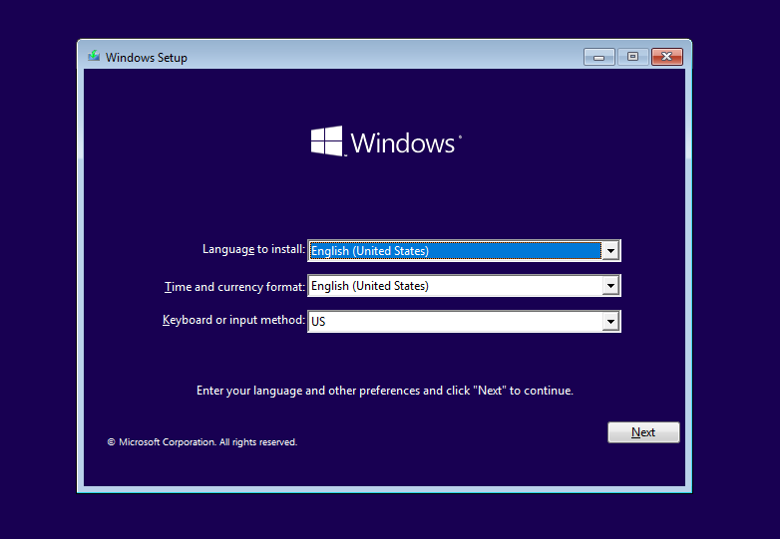

* 1. Begin Installation

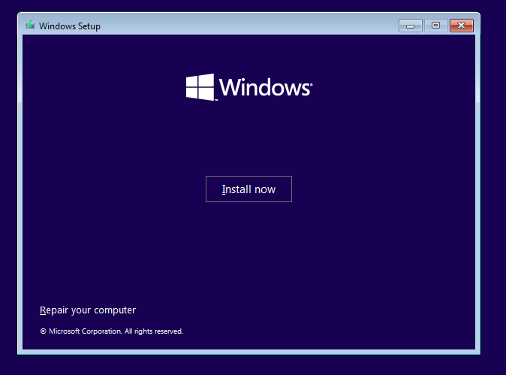

* 1. Enter Product Key to Activate Windows or skip this step

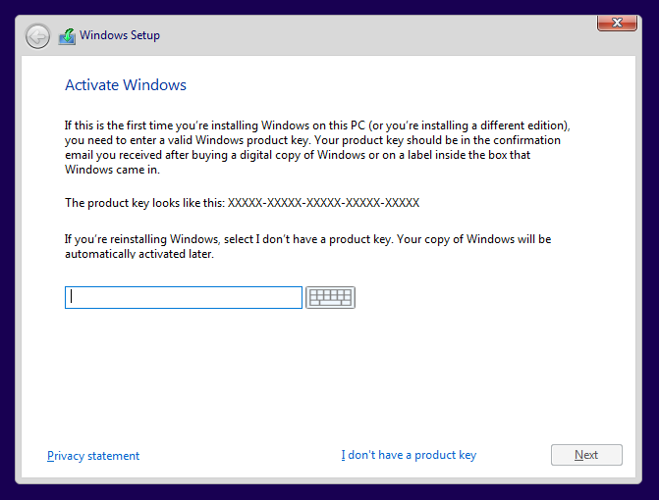

* 1. Select which type of Windows you want

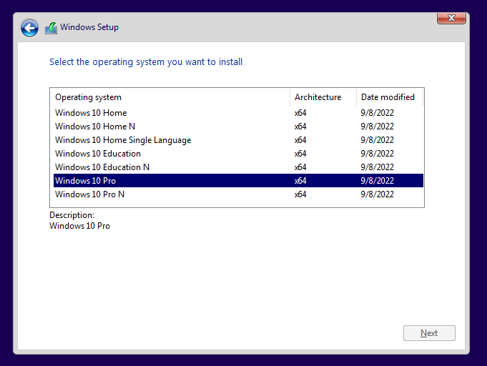

* 1. Accept License Terms

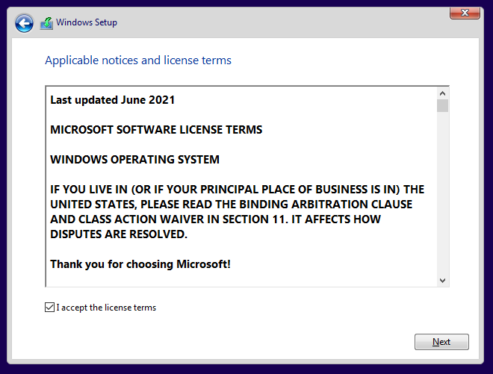

* 1. Select which type of installation you want (preferably custom)

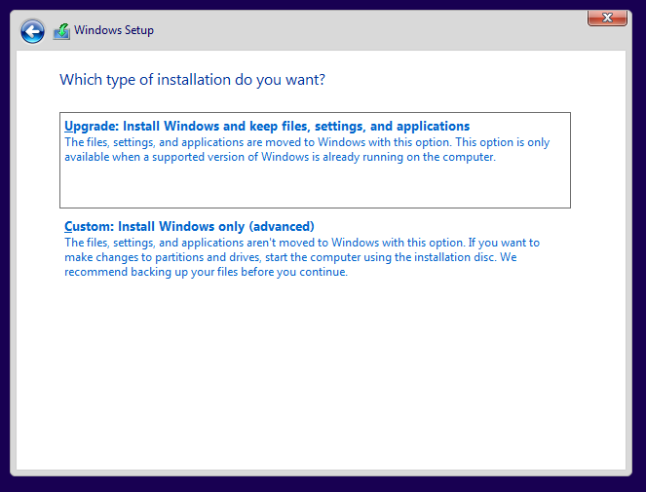

* 1. Select Windows Installation Location & Allocate Partition

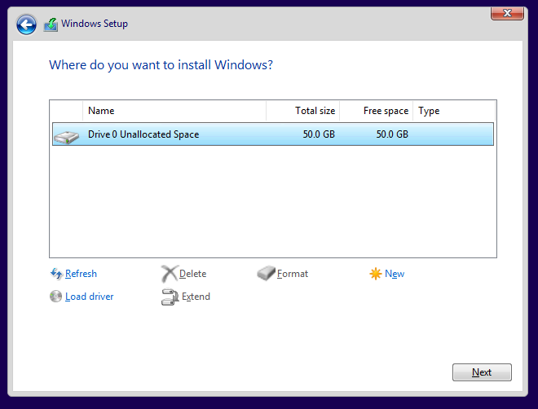

* 1. Installation of Windows Begins

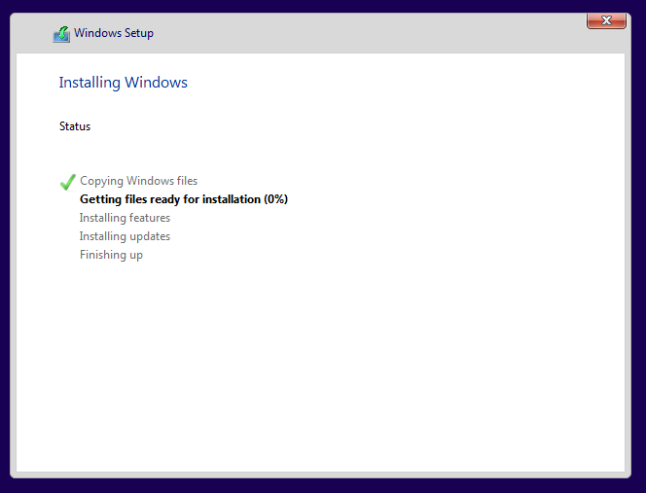

* 1. Repeat for Windows Server

1. **Once installation is finished, open both Windows Client and Server**

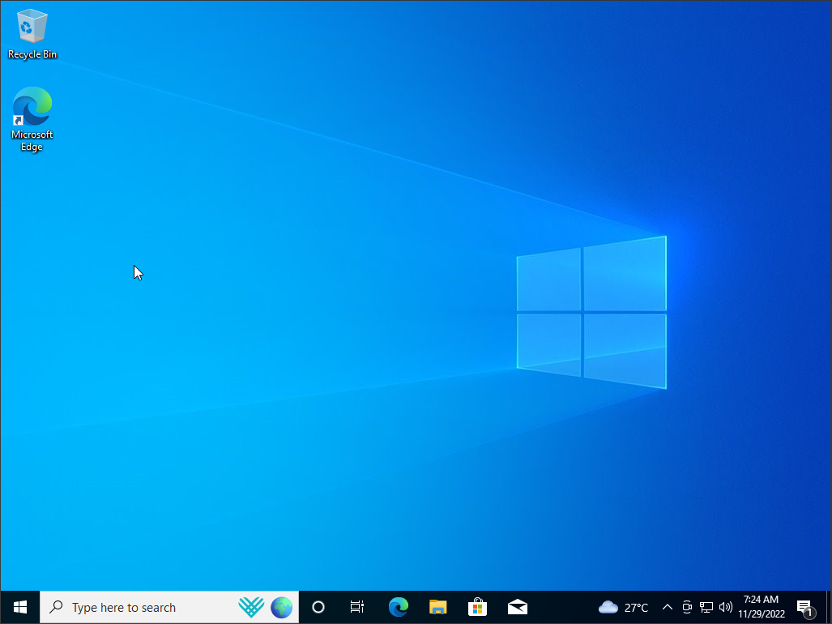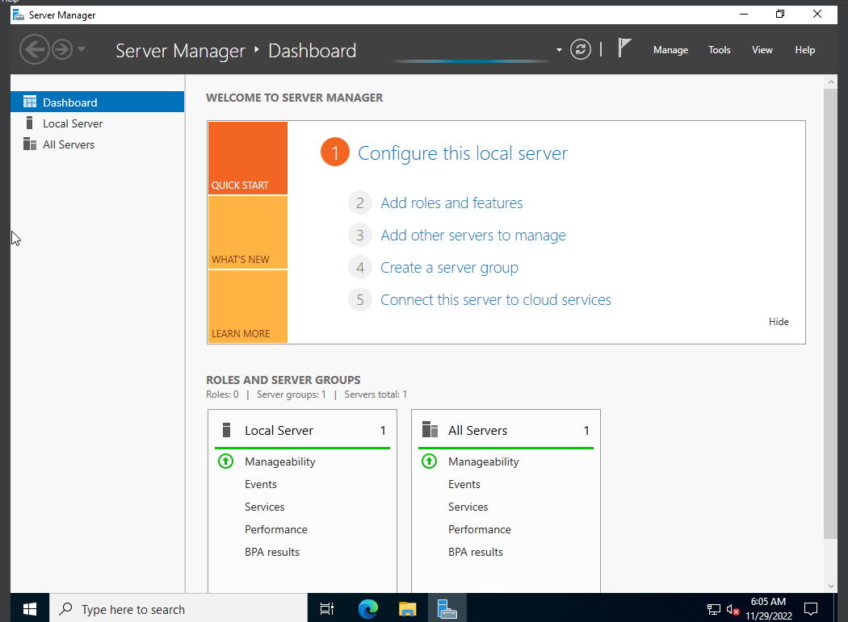

**Network Connection (IPv4) Setup**

1. **Open Windows Server**

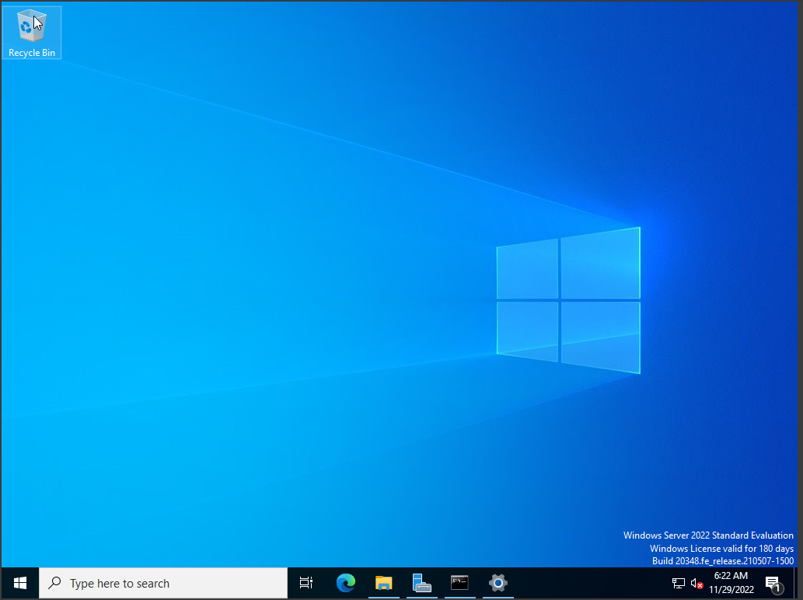

1. **Access Network & Internet Settings**

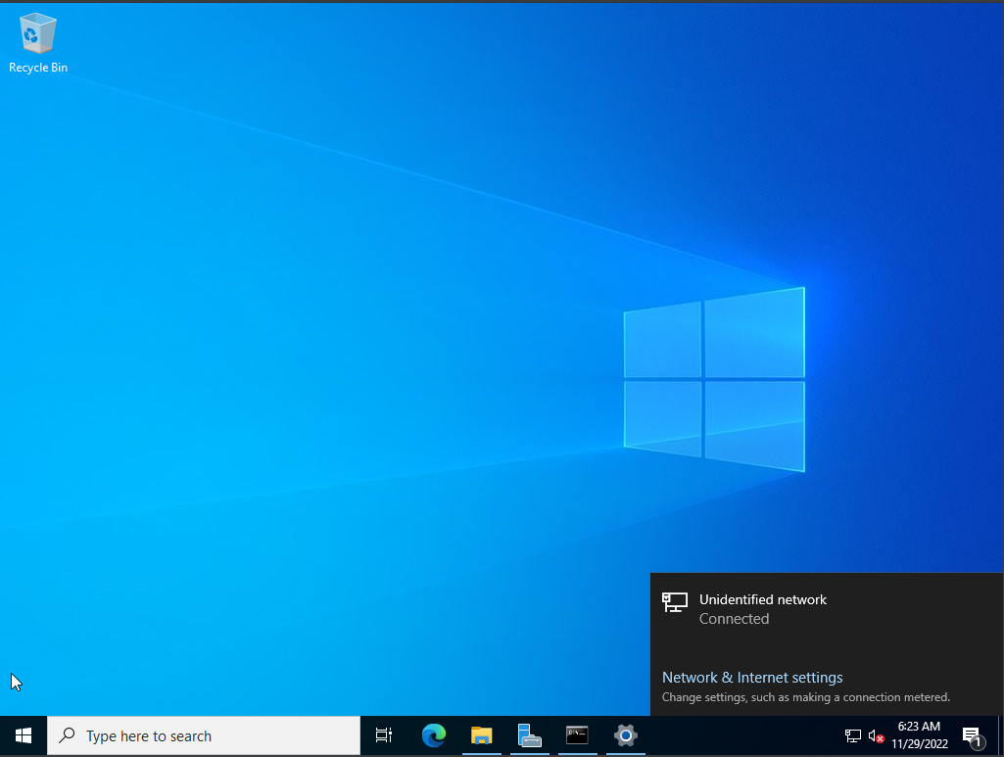

1. **Open Network & Sharing Center**

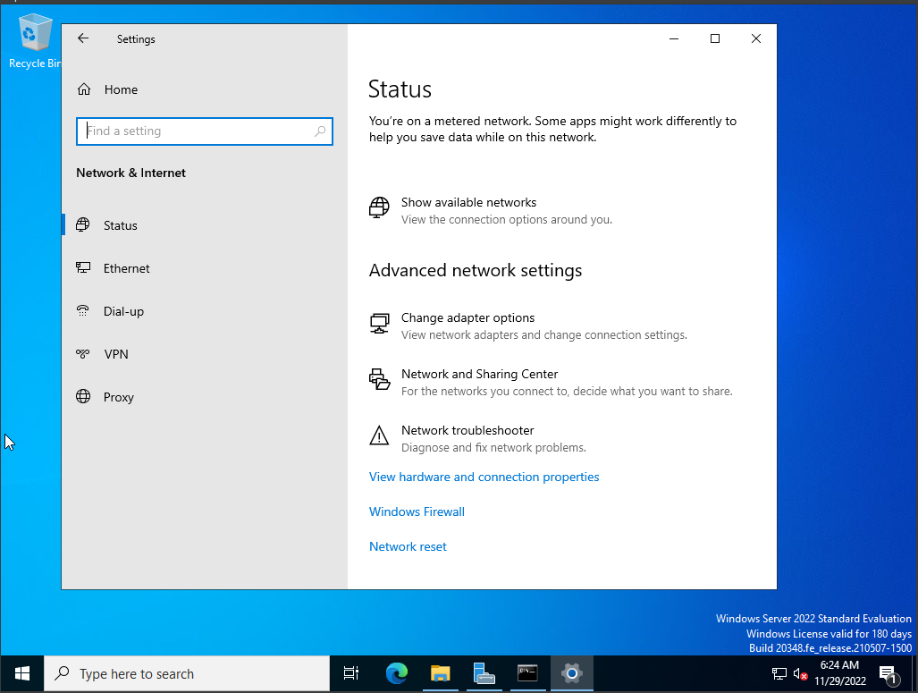

1. **Click Change Adapter Settings**

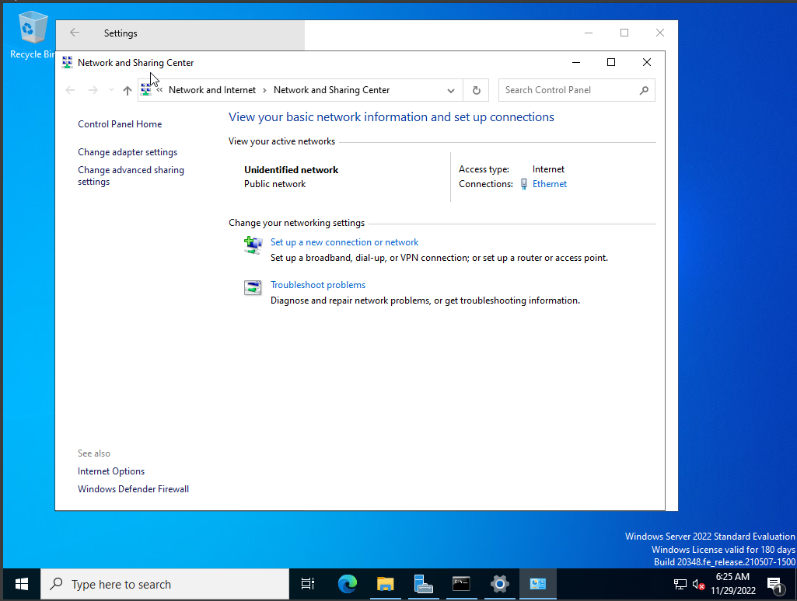

1. **Right Click Ethernet and Press Properties**

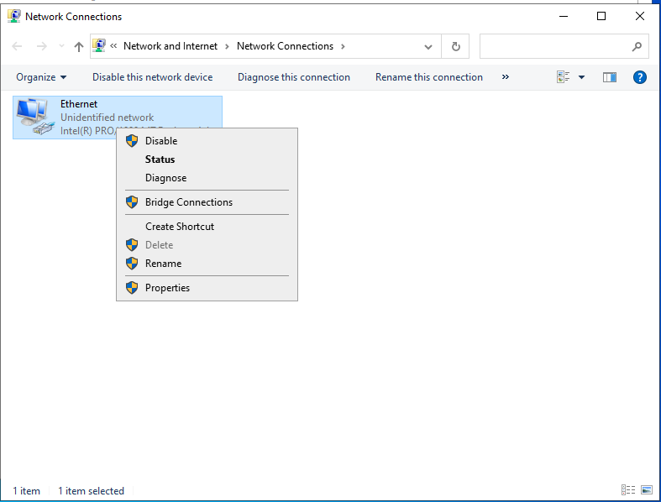

1. **Select Internet Protocol Version 4 and Press Properties**

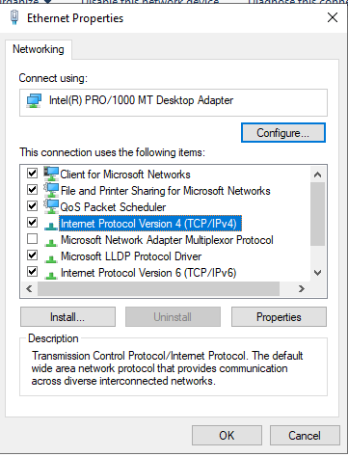

1. **Set Server IP address and Subnet Mask and Click OK**

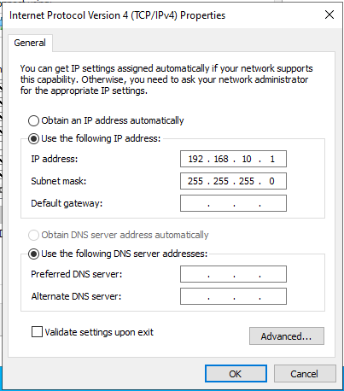

1. **Do the same for Windows 10 Client and then check connectivity status**

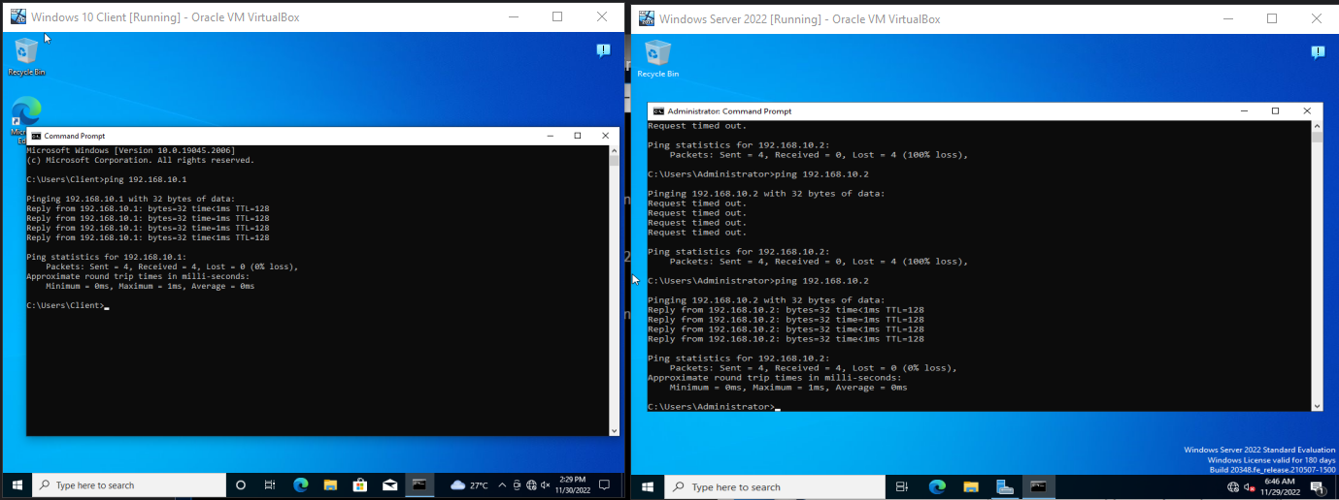

**Create a Website to be Hosted on the Server**

1. **Open an IDE of choice for website developing (personally VS Code)**



1. **Create your website**

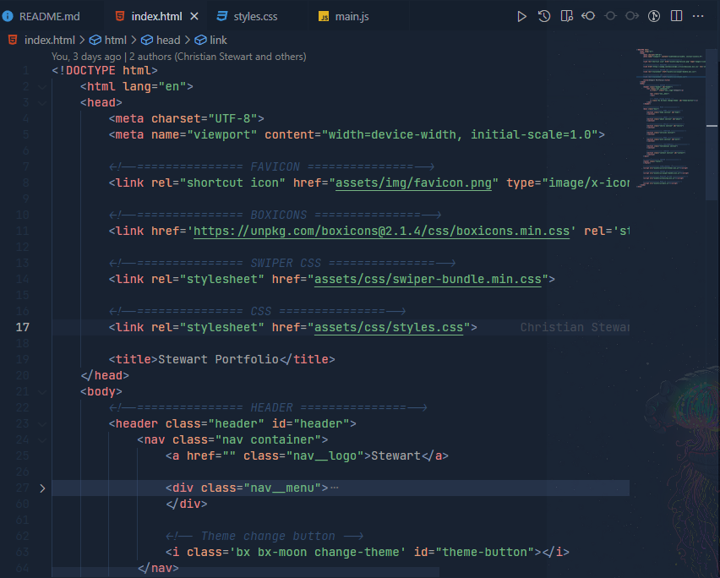

1. **Once finished, preview your website**

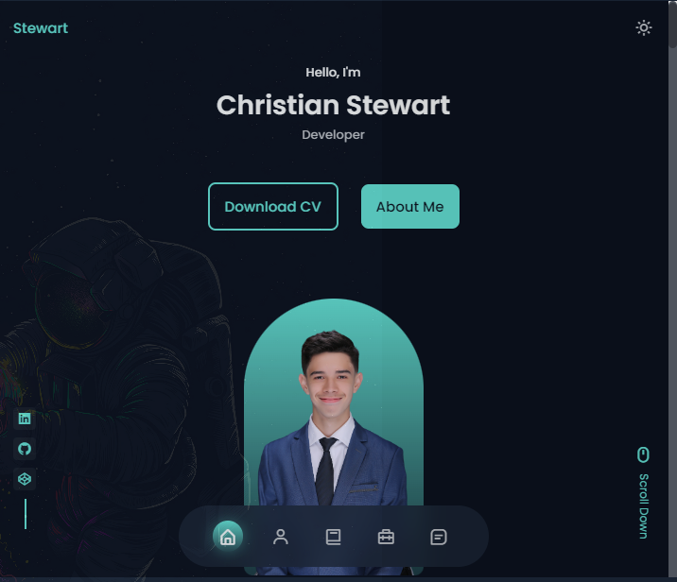

1. **Add website to the Windows Server Virtual Machine**

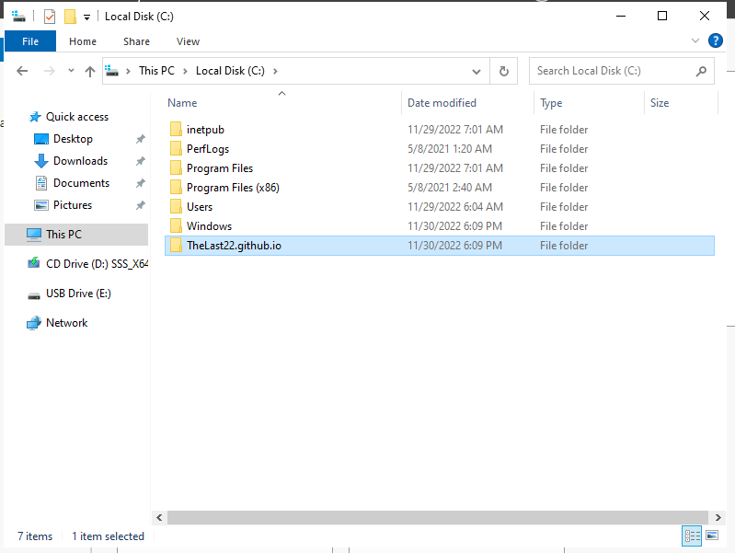

**Install IIS using Server Manager**

1. **Open Windows Server VM and Open Server Manager**



1. **Click add roles and features**

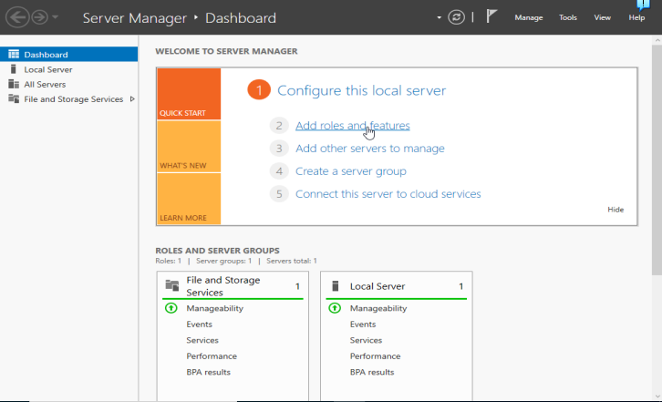

1. **Click Next**

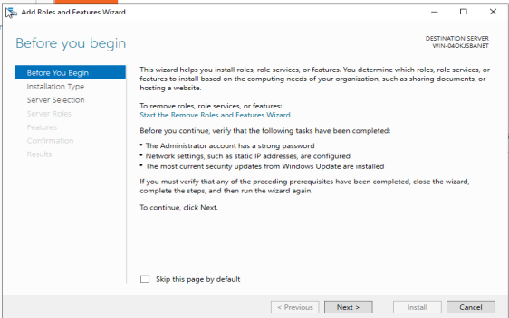

1. **Select role-based/feature-based installation**

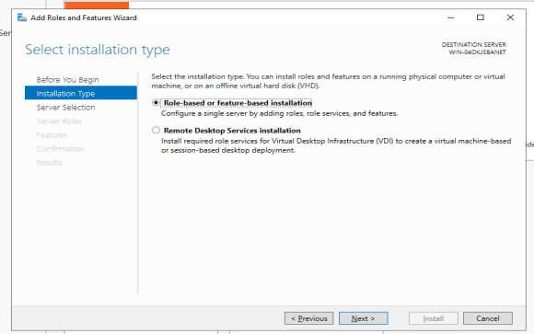

1. **Select Destination Server and click next**

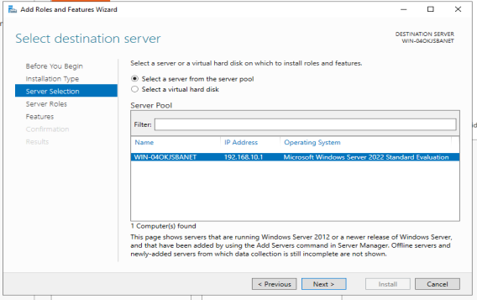

1. **Select Web Server (IIS) and click next**

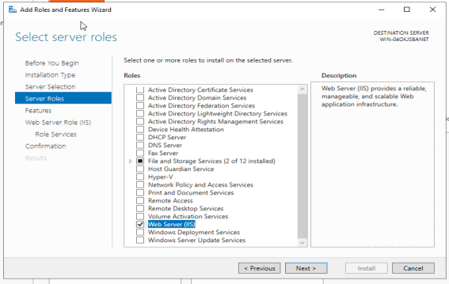

1. **Click Next as we do not require extra features**

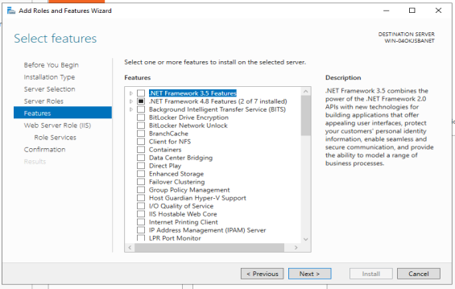

1. **Click next until you confirm install selections and then press install**

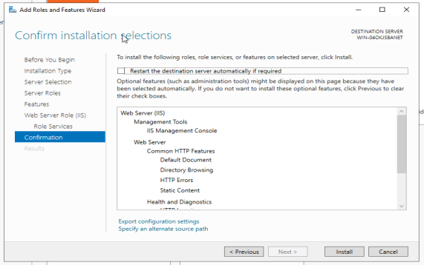

1. **Wait for installation to finish and click close**

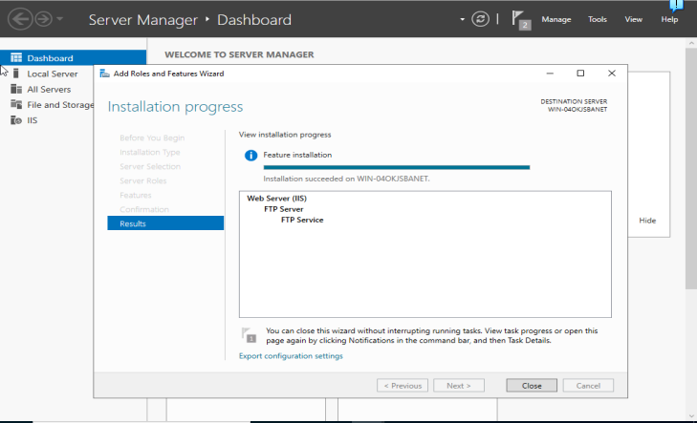

1. **Run web browser to verify IIS is running normally**

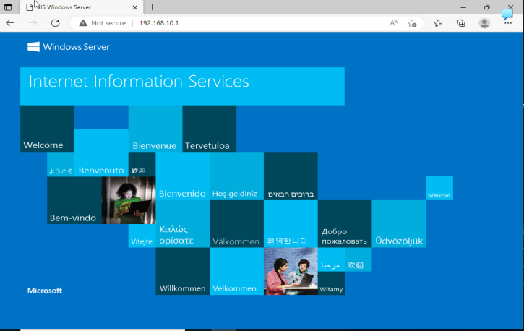

1. **Open Server Manager, click Tools, and select Internet Information (IIS) Manager**

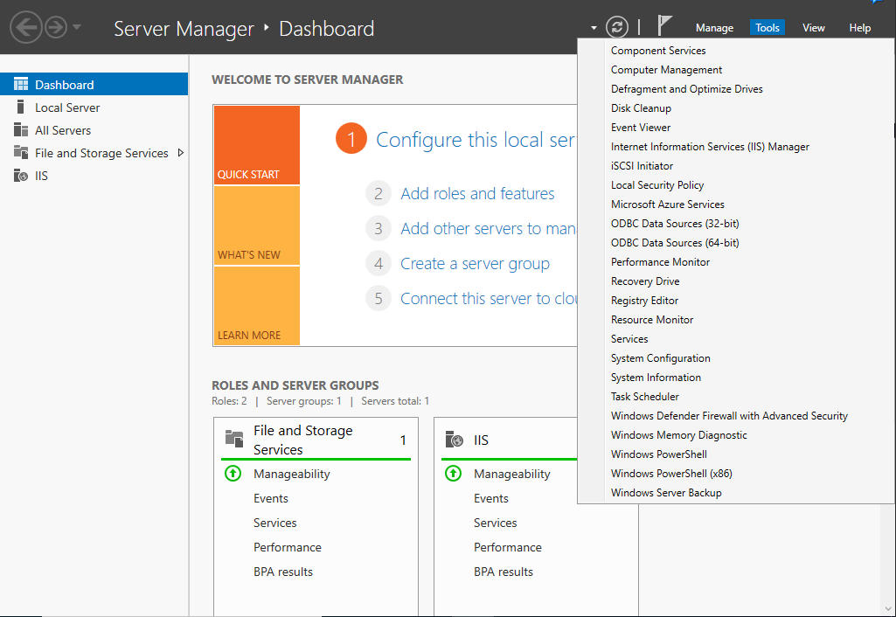

1. **Right click on Default Website, click on Manage Website and then select Advanced Settings**

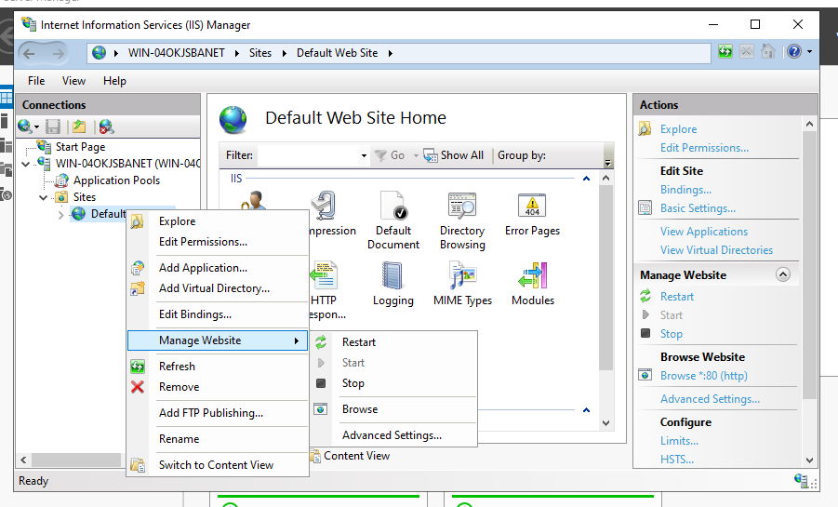

1. **Click on the Settings icon of the Physical Path option**

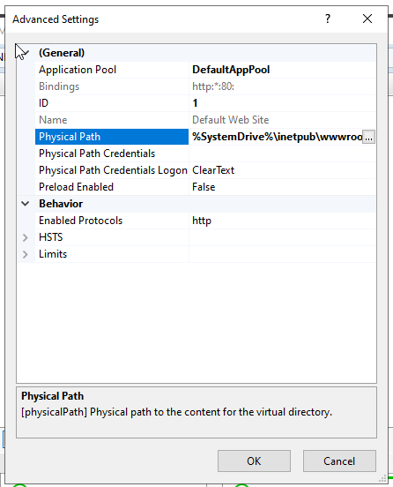

1. **Locate and select the website root folder and click OK**

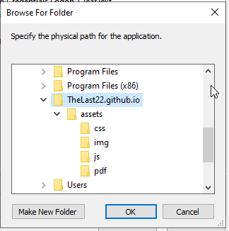

1. **Click OK to continue**

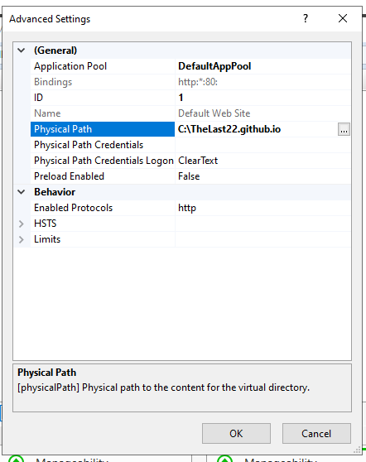

1. **Select Default Document to specify the default file in the root folder you provided**

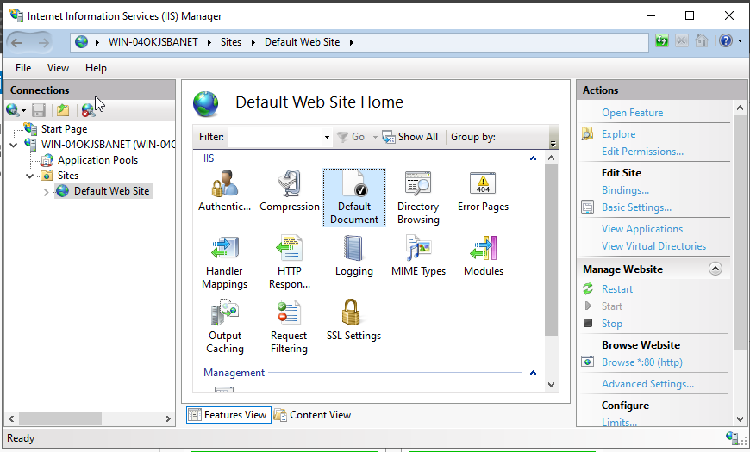

1. **If your index page on the website is not named in the list, then add it – otherwise continue to next step.**

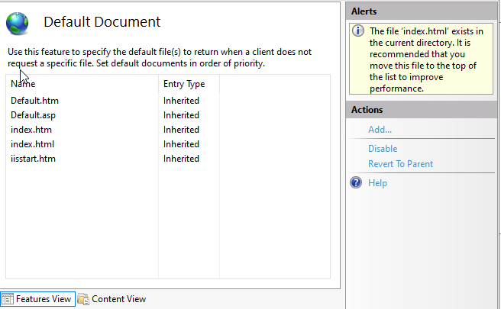

1. **Test it out in the browser using the server’s IP address using the Windows Server OS**

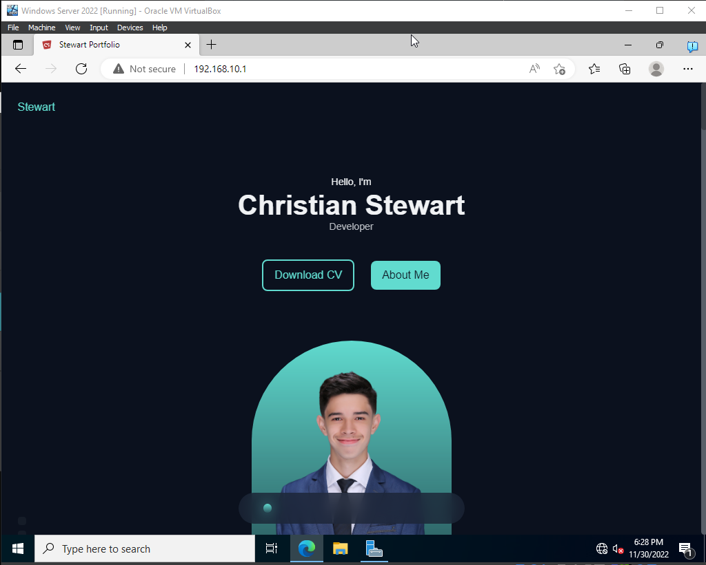

1. **Access the website using the Windows Client OS in the browser**

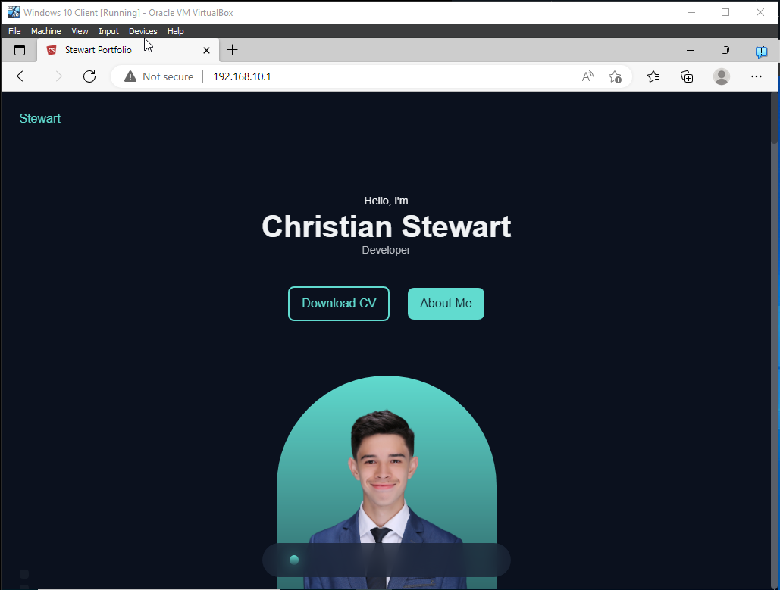

**Apply Digital Certificate on the Website**

1. **Open Windows Server VM and Open Server Manager**

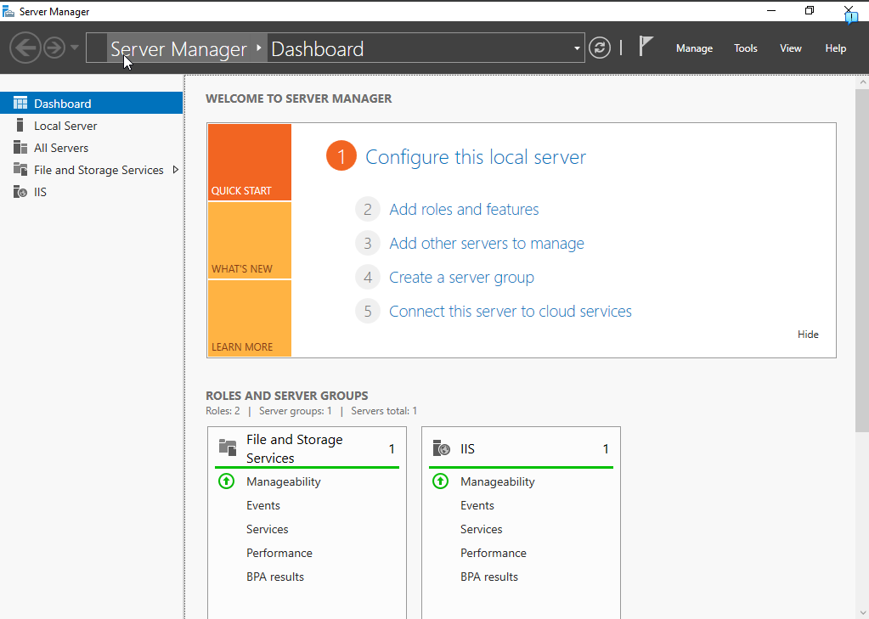

1. **Click Tools and Select Internet Information Services (IIS) Manager**

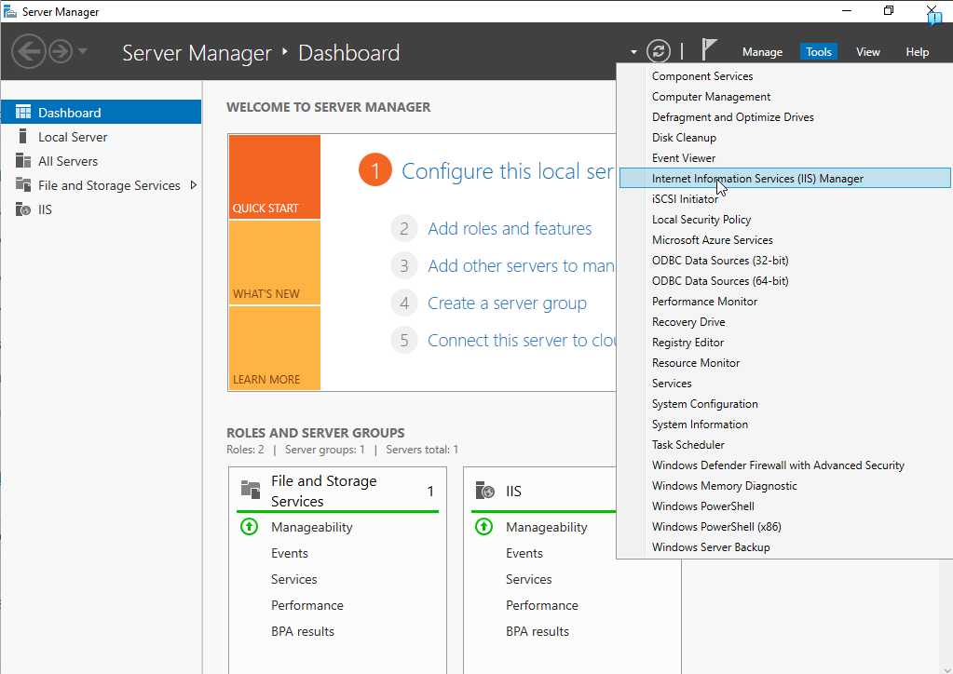

1. **Select your Localhost on the connections panel and then click Server Certificates**

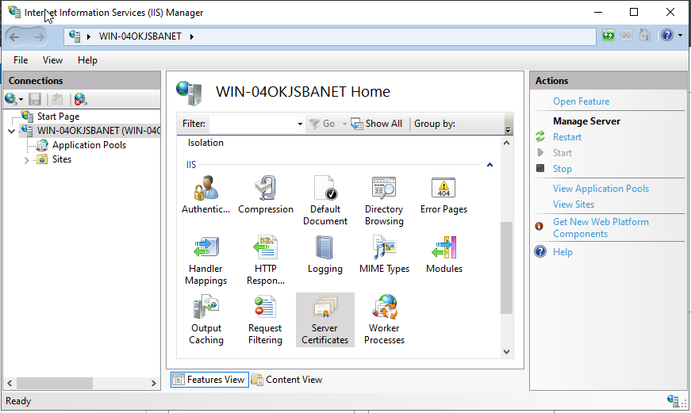

1. **Click on Create Self-Signed Certificate**

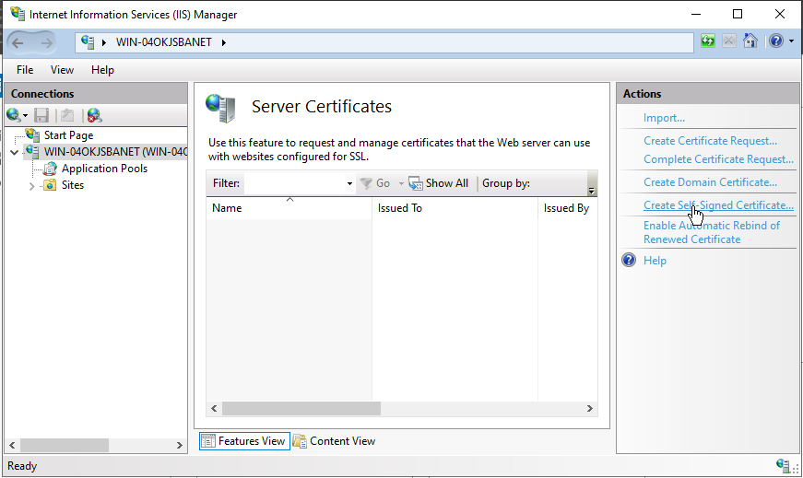

1. **Enter a name for the Certificate and Select Certificate Type and press OK (Personal type for mine)**

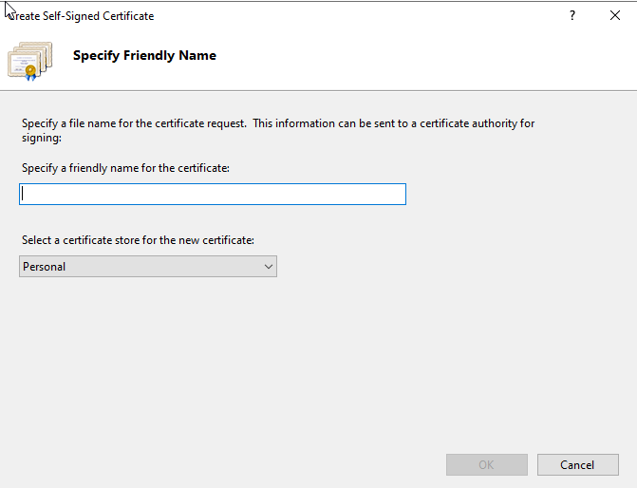

1. Once created, Double-click the certificate to check its contents, then click OK

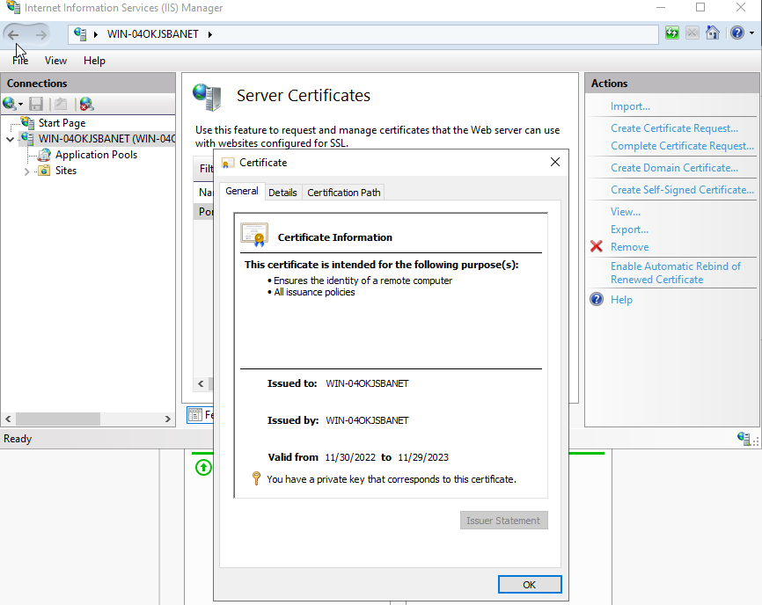

1. Go to Default Web Site in Connections Panel, and select Bindings from the Actions Panel on the right

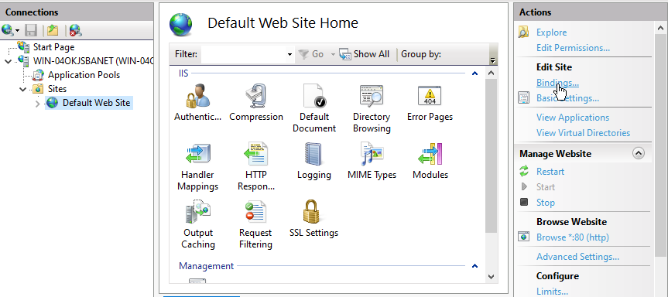

1. Add a HTTPS Binding by clicking the Add button

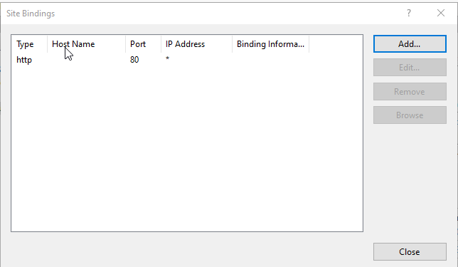

1. Select HTTPS as Type, enter a host name and choose the SSL Certificate you created beforehand. Click OK after everything is done

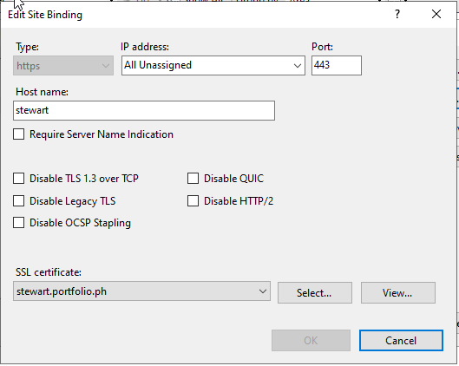

1. Test it on Browser in Windows Server OS

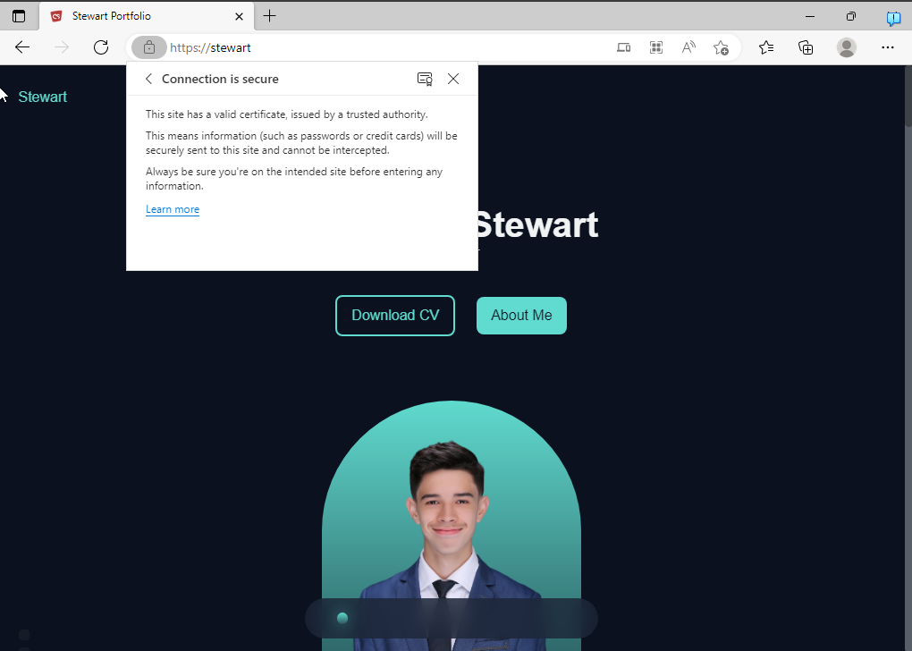

1. Test it on Windows Client browser using the host name

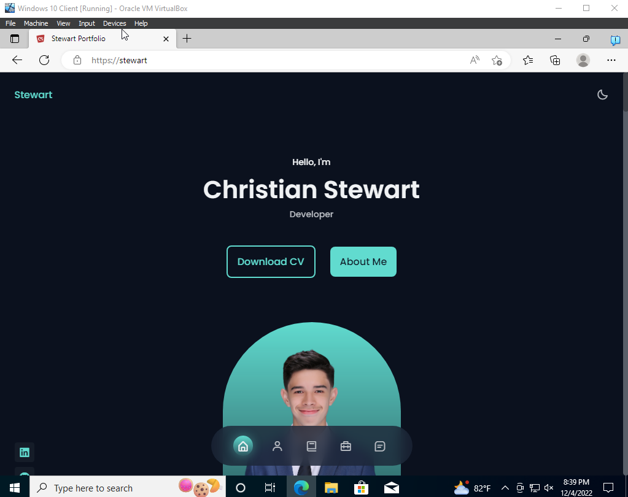

1. Check the Certificate Details

